**Topic- Microservices with Spring Boot 3 and Spring Cloud**

**Q) Creating Microservices for account and loan**

In this hands on exercises, we will create two microservices for a bank. One

microservice for handing accounts and one for handling loans.

Each microservice will be a specific independent Spring RESTful Webservice

maven project having it's own pom.xml. The only difference is that, instead of

having both account and loan as a single application, it is split into two

different applications. These webservices will be a simple service without any

backend connectivity.

**Solution:-**

**Code:-**

**AccountController.java**

package com.cognizant.account;

import org.springframework.web.bind.annotation.*;

@RestController

@RequestMapping("/accounts")

public class AccountController {

@GetMapping("/{number}")

public Account getAccountDetails(@PathVariable String number) {

return new Account(number, "savings", 234343);

}

static class Account {

private String number;

private String type;

private double balance;

public Account(String number, String type, double balance) {

this.number = number;

this.type = type;

this.balance = balance;

}

public String getNumber() { return number; }

public String getType() { return type; }

public double getBalance() { return balance; }

}

}

**OUTPUT:**

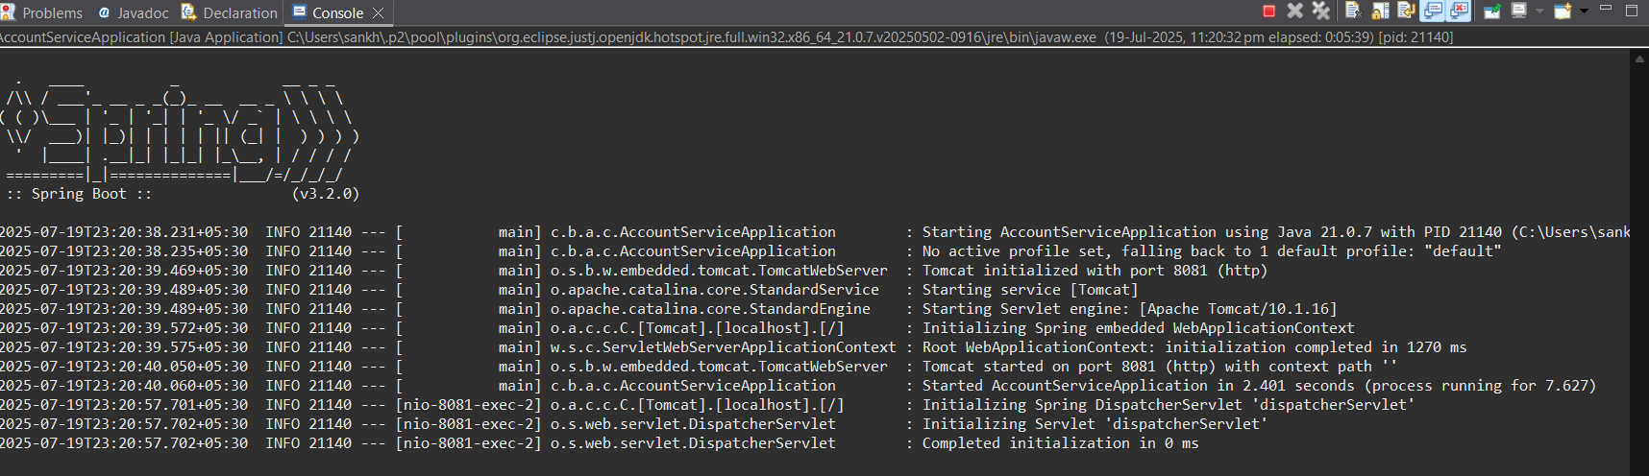

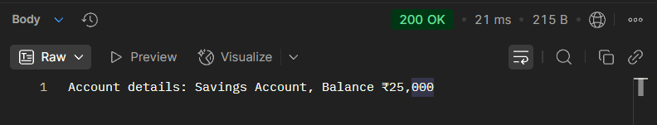

**LoanController.java**

package com.cognizant.loan;

import org.springframework.web.bind.annotation.*;

@RestController

@RequestMapping("/loans")

public class LoanController {

@GetMapping("/{number}")

public Loan getLoanDetails(@PathVariable String number) {

return new Loan(number, "car", 400000, 3258, 18);

}

static class Loan {

private String number;

private String type;

private double loan;

private double emi;

private int tenure;

public Loan(String number, String type, double loan, double emi, int tenure) {

this.number = number;

this.type = type;

this.loan = loan;

this.emi = emi;

this.tenure = tenure;

}

public String getNumber() { return number; }

public String getType() { return type; }

public double getLoan() { return loan; }

public double getEmi() { return emi; }

public int getTenure() { return tenure; }

}

}

**OUTPUT:**



